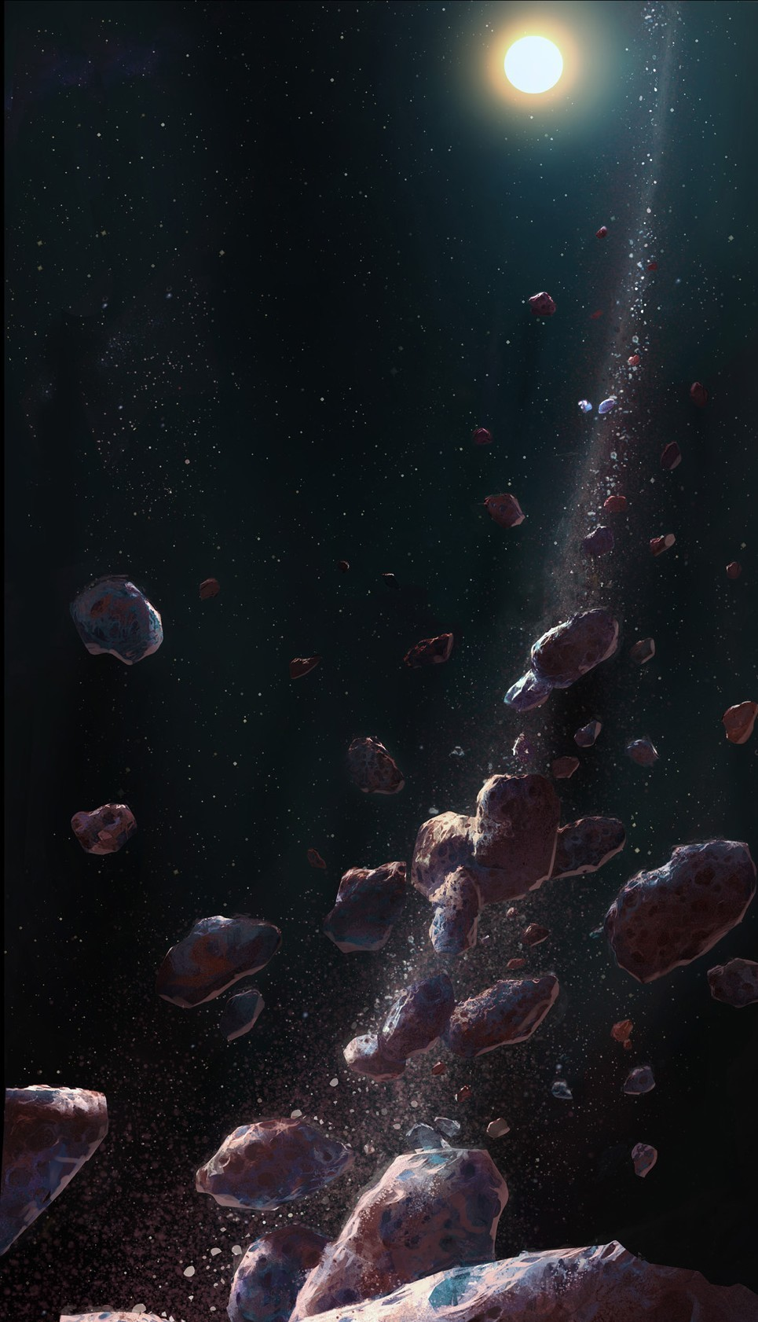TEMPEL

Contents

introduction 3

Factions 3

i. Generalities 3

The beginning 4

i. is it a game or a simulation? 4

Gameplay 5

# introduction

Tempel isn’t just a game.

It is a grown-ass mother-of-all-simulation-games epicly concentrated ball of unrivalled complexity, in a universe filled with spaceships, aliens, weapons of mass destruction, robots, wooooah-esque moments and even alien robots. Featuring a development time longer than your great-grand-father’s lifetime.

# Factions

## Generalities

Every faction in Tempel is unique. It has its own ways and means, and its distinctive objectives. However, all factions share a set of attributes, and their definitions are what makes them novel. A list of these attributes and associated explanations can be found below :

* **Goals :** Every faction has specific objectives which will influence all of its actions. A faction can seek for money, security, independence, the extermination of every other faction and plenty of others. Note that objectives can change temporarily or permanently as a consequence of the events taking place in Tempel's system or of scientific breakthroughs.
* **Resources :** The list of resources the faction has a use for. The ones it will need to grow, build new infrastructures and ships, and sustain its population. One faction is unlikely to have a use for every resource in the game, but its list may evolve depending on its research orientation and/or specific events. One faction may per example find value in a newly discovered mineral that can be used in high-tech propulsion systems : This mineral would be added to the faction's current resource list.
* **Industry :** The means used by a faction in order to gather resources and build products. It includes various harvesting means like farming, asteroid mining, processing, solar energy harvesting and the faction's manufacturing methods : Gigantic ground factories, orbital shipyards, asteroid conversions, energy & matter transformation, ...
* **Population :** A faction's population is the flesh that operates all of its organism. It might be composed of lifeless beings, mechanicals agents, a single powerful entity or individuals like humans, more or less united under a single banner.
* **Organization** : How the population of the faction is organized. Is it a free society in which everyone choose his speciality and attribution, a caste system with roles decided at birth, a medieval estate system or a strict military hierarchy. A faction's organization determines its flexibility and its bottlenecks. Per instance, a medieval system would be unable to make decisions if separated from its head until someone seize the opportunity and imposes himself as a new leader.
* **Politics :** The ways decisions are made at the highest level. In a military hierarchy, orders are absolute and centralized whereas in a more liberal organization decisions are discussed and voted by a group of people. Some systems prove to be more reactive to their environment than others, and the wisdom of their decision will vary depending on the actual executives.
* **Environment :** The main type of infrastructure and living conditions of a faction's population. Some tend to prefer living in ground based colonies filled with vertical buildings and a strictly ordered road system, some tend to live on space habitats and avoid getting their foot dirty as much as possible. In each and every case, this attribute will affect what type of resources will need to sustain these infrastructures and where it will settle in the system.
* **Technology :** This attribute describes the main technologies mastered by a faction. They may be shared between several factions and sub-factions or they may be unique. As the factions progress and put more effort in research, they may open new development fields and it may have a radical impact on the rest of their society.
* **Navigation (Sensors + Propulsion) :** A faction's method to travel in space. It includes both sublight and FTL propulsion systems and detection systems.
* **Weaponry :** The weapons used by a faction in order to defend itself or lead hostile operations against other factions. Weapons exist in a large panel of shapes and sizes, from fast tracking anti-fighter turrets to gigantic strategic grade weapon built on asteroids. Some factions may have a wide range of specialized weapons or a limited number of multipurpose ones. They may also greatly vary in effectiveness as some factions are more inclined towards war than others.
* **Diplomacy :** The means and will characterizing a faction's effort to conduct negotiations. Some may seek peace of non-violent agreement in every situation while others may simply not be able to understand the concept of diplomacy, nor the existence of other factions as something else than a nuisance.
* **Spaceships :** The constructs used by a faction to operate in space. Ship purpose may greatly vary between factions and models and their design will follow their faction's history and goals.
* **Tactics :** A faction's tactics describe the way it will lead its operations in the system. A strictly organized faction may use precisely timed recon operations to gather Intel on other factions while a civilian faction could simply try to harvest resources locally without monitoring other factions

// Description of every faction using the aforementioned attributes / Lots of pages

# The beginning

Tempel is a simulation game. It will simulate the behaviour of several lifeforms trying to colonize a solar system isolated from the direct influence of every major faction. Every faction has its own way of developing, its own goals and ideology, its own way to defend itself and wage war, its own resource system and its own mechanics. They are all different and they've all been driven to Tempel's system for various reasons, with various means. In this very system they will try to prosper, fulfil their objectives and interact with whoever they meet, with whatever Intel they have about them.

## is it a game or a simulation?

Both of them! But this game will mainly rely on the simulation part. Because the player will influence the simulation in some proportion. But will not command or act with the different races of the simulation. This game is so intended for some who like to watch a simulation and the consequences of their actions. We can take the game “The Last Federation” to illustrate our purpose.

// Beginning of a game description / Few pages

# Gameplay

// What the player does, to what extent he influences the factions // Few pages